Step Up To The Plate Carol Thompson #17982
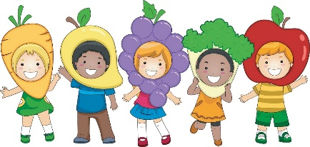
Susan Robertson #17983
salt.childcaretraining.gmail.com

My Plate- United States Department of Agriculture www.choosemyplate.gov
Kids Health In The Classroom https://classroom.kidshealth.org https://kidshealth.org/en/parents/myplate.html
Preschool Nutrition Theme https://www.preschool-plan-it.com/preschool-nutrition.html
A Nutrition Learning Center for Child Care Programs https://www.healthypreschoolers.com/
The Preschool Initiative
http://thefoodtrust.org/uploads/media_items/the-preschool-initiative.original.pdf
Nutrition.gov https://www.nutrition.gov/
US Government Publishing Office https://catalog.gpo.gov
Super Simple Songs and The Learning Station – You tube

Chef by Amanda Askew
Dragons Love Tacos by Adam Rubin
Eat Your Colors by Amanda Miller
Eating the Alphabet by Lois Ehlert
Green Eggs and Ham by Dr. Seuss
Gregory, the Terrible Eater by Mitchell Sharmat
I Want to Be A Chef by K. Ruiz
I Will Never Not Ever Eat a Tomato by Lauren Child
Llama Llama Yum Yum Yum by Anna Dewdney
Monsters Don’t Eat Broccoli by Barbara Jean Hicks
My Food, Your Food by Lisa Bullard
Pancakes, Pancakes by Eric Carle
Peanut Butter and Jelly by Nadine Bernard Westcott
Picky Eater by Michael Gordon
The Berenstain Bears and Too Much Junk Food by Stan Berenstain
The Picky Eater by Betsy Parkinson
The Very Hungry Caterpillar by Eric Carle
Why Should I Eat Well? By Claire Llewellyn
The Monster Health Book by Edward Miller
The Donut Chef by Bob Staake

Pancakes for Breakfast by Tomie DePaola

